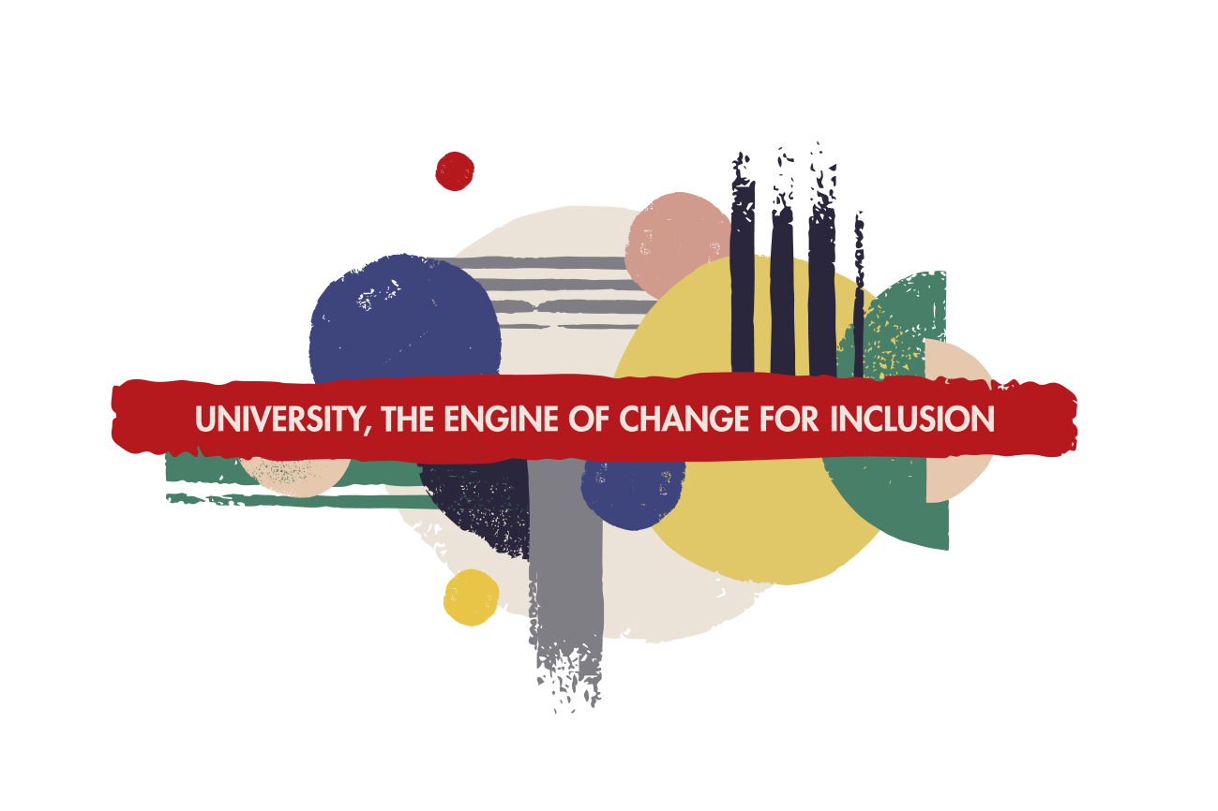

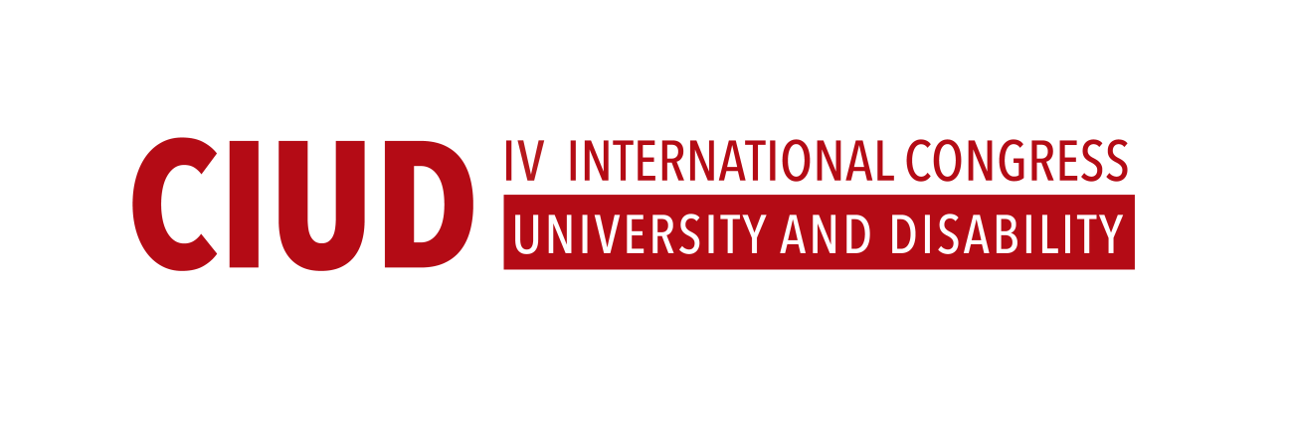

MANIFEST

We, the Universities, institutions and experts in the field of education and disability, who are to participate at the 4th edition of the International Congress of University and Disability, committed to advancing inclusion in higher education, hereby express and declare the following:

WHEREAS, education is a universal right and is recognised under international human rights law, as well as the Convention on the Rights of Persons with Disabilities (CRPD), among other International Human Rights Instruments.
WHEREAS, the Convention against Discrimination in Education, as such, has the duty not only to proscribe any form of discrimination in education but also to promote equality of treatment and opportunities for all.
WHEREAS, the right to inclusive education refers to the right of all persons, without distinction and in equality of condition, to experience education and, as a consequence, we understand that the right to education must be interpreted, from this moment forward, as the right to inclusive education.
WHEREAS, disability is part of human diversity.
WHEREAS, the right to education encompasses both quality and inclusion in education, in accordance with its founding values such as liberty, equality, dignity and solidarity.
WHEREAS, the Office of the United Nations High Commissioner for Human Rights (2013) recognizes inclusive education as the most appropriate avenue for the States to ensure universality and non-discrimination of the right to education for all.
WHEREAS, we commit ourselves to working tirelessly for the full implementation of 2030 Agenda, especially the Sustainable Development Goals 4 and 10, that ensure inclusive and equitable access to all levels of education and vocational training for all .
WHEREAS , the Europe 2020 strategy (EU’s Agenda for growth and jobs) has as its main objective to reduce early school leaving rate to less than 10 %, referred to persons between 18 and 24 years old, that should at least possess a school leaving qualification.
WHEREAS, we express our concern for the low participation rates of students with disabilities in higher education, as well as for early school leaving and barriers that they encounter in the academic field.
WHEREAS, we highlight that women with disabilities are the most affected social group in terms of access to education and the quantity of barriers they encounter while accessing university.
WHEREAS, according to the Convention on Rights of Persons with Disabilities, States Parties shall ensure an inclusive education system at all levels and lifelong learning, in compliance with the Article 24 of the aforementioned Convention.
WHEREAS, we support the General Comment on Article 24 of the Committee on the Rights of Persons with Disabilities which recognizes that persons with disabilities should be active participants through their representative organizations in planning, management, supervision and evaluation of inclusive education policies.
WHEREAS, the CRPD Committee in its General Comment 4 on Article 24 (2006) establishes that in order to guarantee the right to inclusive education, all aspects of both formal and informal education should go through a process of transformation, from a cultural, political and social point of view, in order to provide room for different identities and needs of each student, as well as to commit to eliminate barriers that limit this possibility.
WHEREAS, we highlight the importance of some of the concluding observations of the CRPD Committee (as a UN human rights treaty body) on the final reports presented by States Parties, where is a constant requirement to establish effective monitoring and review mechanisms to ensure that legislation, strategies and public policies relating to the application of article 24 comply with the States parties obligations throughout their territories, alleged structural exclusion and segregation on the basis of disability of persons with disabilities from the mainstream education system.
WHEREAS, the CRPD Committee considers that the information available reveals violations of the right to an inclusive and quality education in the majority of States Parties. These violations are primarily related to certain features of the education system that have been maintained despite reforms and that continue to exclude persons with disabilities — particularly those with intellectual and/or psychosocial disabilities or multiple disabilities — from mainstream education on the basis of assessments conducted according to the medical model of disability.
WHEREAS, as the CRPD Committee indicates, it appears that the difficulties of students with disabilities encounter are resolved on an ad-hoc basis. In most cases, the future of a student with disabilities depends on the will of his or her family and that of the administrative and lecturers involved, rather than on the realization of his or her right to an inclusive and quality education.
WHEREAS, the Committee observed that measures adopted in post-secondary teaching institutions are one-off and not systematic, and the post-secondary teaching system does not adequately accommodate persons with disabilities.
WHEREAS, persons with disabilities encounter many obstacles and barriers regarding accessibility and inclusion in higher education at all levels.

WE HEREBY DECLARE THE FOLLOWING

We consider that inclusive education has a positive impact on education, economy, personal growth and society.
We commit to promote, through exchange of personal and specialized experiences and good practices at the Congress, effective implementation of a model of inclusive education that guarantees the presence, participation and progress of all students with disabilities.
We determine that inclusive education is a process that requires continuous changes and updates of regulatory frameworks, teaching innovations, methodological strategies, environmental adaptations and adjustments and equality assessments, along with active participation of all teaching and university staff, in order to transform policies and practices within the academic field.
We highlight the need for regulatory frameworks in order to guarantee the right to equal opportunities, reasonable accommodations and positive actions which are essential in order to continue progressing.
We consider necessary to develop mandatory Action Protocols that will ensure that services offered by Universities are in line with the right of all persons without distinction and on an equal basis.
We believe that Universities have a social responsibility which encompasses inclusion and good diversity management, as well as the responsibility to develop and implement effective transversal policies that ensure the aforementioned aspects, as well as to serve as a guide to other agents that belong to previous educational stages.
Inclusion is a principle of quality and excellence within university frameworks and, thus, it must be considered within the strategic plans of universities, as well as during the processes of accreditation and evaluation of institutions and university teaching staff. It must also be taken into consideration for the international university rankings on the quality of universities and the assessment scales at the Campus of International Excellence.
We believe it is vital that national and regional Institutes for Education Evaluation and Quality take into account the factor of accessibility while evaluating educational programmes and indicators of inclusion at Universities.
We believe that in every field of knowledge the research plays a key role in social progress and development through promoting and innovating in fields of accessibility, inclusion and equality.

Therefore,
We commit ourselves to make network of Universities, experts and Congress participants in order to create resources, synergies and strategies to facilitate the transition of students with disabilities from secondary education to higher education.
We commit ourselves to contribute to build of an integrated model of action based on the principles of the social model and human rights model of disability by promoting a supportive and inclusive learning environment.
We commit ourselves to promote within our communities the presence, access and completion of higher education studies by students with disabilities.
We commit to advance the training of school councillors and teaching and research staff at all educational levels, in order to provide the skills and values that are essential and necessary for inclusive educational environments.
We commit to support teaching innovations, as well as lines of research conducted in the academic field through exchange of ideas at all educational levels and environments in which we will be involved.
We commit ourselves to impulse full inclusion of persons with disabilities into all areas that form part of student lives such as sport, culture and leisure, in order to feel that they are a part of a university community.
We commit ourselves to create inclusive and variegated Universities in all of their areas, taking into account the principal values of human rights.
We commit ourselves to promote the participation of persons with intellectual disabilities in Universities, through programs designed in line with their needs.
We commit ourselves, in compliance with human rights, to support improvements of study programs in order to introduce the basic knowledge of those who design and develop infrastructures, contents, services, devices and accessibility policies.
We commit ourselves to work towards achieving the Sustainable Development Goal 4, as well as to reach full inclusion in Universities, until 2030.
We commit ourselves to continue working in order to successfully overcome challenges regarding the application of the Article 24 of the CRPD, taking into consideration its main values such as equality and non-discrimination, equality of men and women and accessibility.

