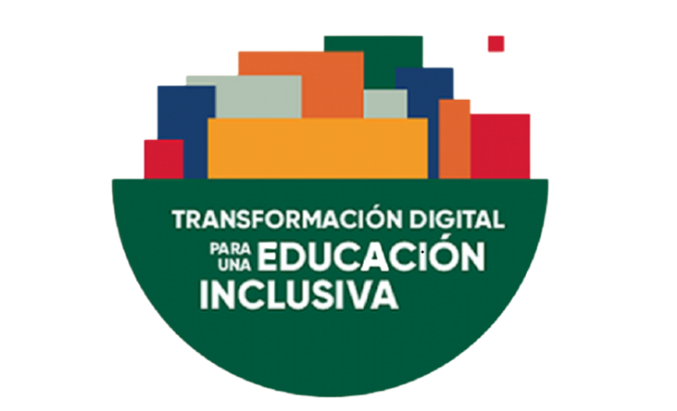

V INTERNATIONAL CONGRESS ON UNIVERSTY AND DISABILITIES
"DIGITAL TRANSFORMATION FOR INCLUSIVE EDUCATION".

MANIFESTO

Recalling that education is a right recognized in the Universal Declaration of Human Rights, and in the Convention on the Rights of Persons with Disabilities (CRPD), among other international human rights treaties.
Recalling the Convention against Discrimination in Education, which prohibits any form of exclusion or restriction of educational opportunities based on any difference.
Recalling that, as recognized by UNESCO, the right to inclusive education refers to the right of all persons, without distinction of any kind and on equal terms, and that, therefore, the human right to education is a human right to inclusive education.
Recognizing that all States that have ratified the Convention on the Rights of Persons with Disabilities must take all recognized measures to provide the right to inclusive education and to ensure that the process and outcomes of developing an inclusive education system comply with the general principles contained in its Article 24.
Embracing the 2030 Agenda, especially Sustainable Development Goals 4 and 10, which aim to ensure equal access for all men and women to quality technical, vocational and higher education, including university education.
Expressing concern about the difficult access of people with disabilities to higher education, the dropout rate in previous educational stages and the existing barriers to their academic progress.
Considering that persons with disabilities still face barriers and obstacles to accessibility, social participation and learning in higher education at all levels and in all modalities.
Considering that people with disabilities are still unable to enjoy equal opportunities in access to teaching and research staff positions.
Taking into account the digital transformation of universities and the new scenarios of digitization in the new teaching and learning processes

WE BRING TO LIGHT

That a truly inclusive education will provide better academic, personal, social and economic outcomes for society.
That inclusive education is a process that requires a permanent updating of regulatory frameworks, teaching innovation, methodologies, resources and accessible environments, equitable assessments and active involvement of the entire education and university system to transform cultures, policies and practices in university contexts.
That the new laws that are being drafted must guarantee the right to equal opportunities, reasonable accommodations and the positive actions that are essential to continue advancing.
That the roles of universities should include social responsibility and university extension policies with an inclusive approach, including specific programs for people with intellectual disabilities.
That it is necessary to undertake positive actions based on intersectionality, with special attention to women with disabilities, persons with disabilities in rural environments and persons with intellectual disabilities.
That in the quality standards and rankings of universities, inclusion should be considered as a value of excellence and this value should be assessable through different indicators.
That in the digital transformation of universities, accessibility and universal design must be taken into account, so that the new virtual teaching methodologies and learning tools do not exclude students with disabilities.
That, through the exchange of experiences, good practices and expertise, in this Congress we must promote the effective implementation of a model of inclusive education that ensures the presence in all areas and activities of university life, social participation and progress of all students with disabilities.
That it is necessary to weave networks with universities, organizations and experts to develop tools, synergies and common strategies that allow us to create networks of universities and experts who work for inclusion.
That it is necessary to guarantee access for people with disabilities to teaching and research staff positions under equal conditions and with the necessary support and positive action measures.
That it is necessary to promote teaching innovation and teaching and learning methodologies that guarantee inclusion, as well as tools that make it possible to assess and evaluate the competencies and progress of all students.
That it is essential that digitization in education takes into account technological, cognitive and social accessibility to promote inclusion and learning opportunities for all students.
That the actions, plans and programs directed towards people with disabilities at the university level, join and converge synergistically with the actions, plans and programs aimed at improving equity and building spaces characterized by peaceful coexistence and non-discrimination within the university campuses.
That the agencies responsible for evaluating and accrediting university degrees and teaching merits incorporate and take into consideration, in each case as appropriate, indicators relating to the universal design of university education and the inclusive policies of each university.

In short, we are committed to continue working to meet the 2030 Agenda and ensure inclusive and quality education for all people.

